Market Cap Weighted Portfolio
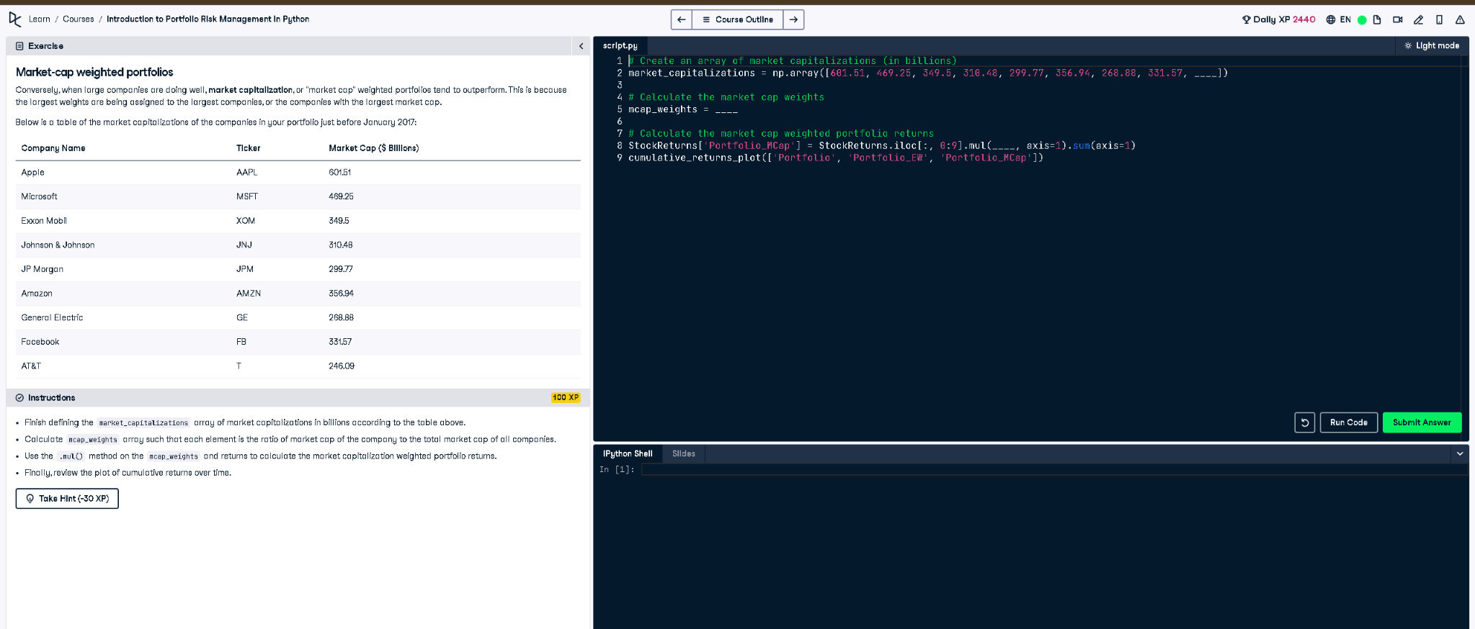

Python Code
# Create an array of market capitalizations (in billions)
market_capitalizations = np.array([601.51, 499.25, 349.5, 310.48, 299.77, 356.94, 268.88, 331.57, 246.09])
# Calculate the market cap weights
mcap_weights = market_capitalizations / np.sum(market_capitalizations)
# Calculate the market cap weighted portfolio returns
StockReturns['Portfolio_MCap'] = StockReturns.iloc[:, 0:9].mul(mcap_weights, axis=1).sum(axis=1)
# Plot cumulative returns
cumulative_returns_plot(['Portfolio', 'Portfolio_EW', 'Portfolio_MCap'])

Explanation (Simple Words)
This code creates a portfolio weighted by market capitalization. Each stock's weight is calculated as its market cap divided by the total market cap. These weights are used to compute the weighted return. Finally, the returns for different portfolio strategies are plotted for comparison over time.

